MASTERNODE GUIDE

WITH COLD-WINDOWS/MAC WALLET & LINUX VPS

This is a guide to install masternode with your wallet in your home pc and Linux VPS. You will have your coins in your PC and your masternode in VPS won't have your coins. Your masternode will just do the earning rewards. For your home wallet you can use Windows, Mac or even Linux. But on VPS side you have to use Linux, Ubuntu 16.04 recommended.

KZC masternode requirements:

- 1000 KZC on balance;

- availability of a dedicated IP-address;

- availability of uninterrupted operation of the system 24 / 7 (network loss must not exceed 30-60min).

The Masternode owner receives 45% of the reward from each new generated block on the network in the queue order of all Masternode. This is the cost for network maintaining Absolutely any user is able to start KZC Masternode, subject to the above conditions.

=================================================================

STEP 1 - INSTALL WALLET ON YOUR PC

* 1. Download latest version of wallet from releases for your OS –

<https://github.com/kzcashteam/kzcash/releases>

STEP 2 - PAY 1000 KZC TO YOURSELF

**2.1** Make sure you have a little more than 1000 KZC in your balance. It can just be 1000 KZC.

You can buy the coins here:

<https://app.bitbay.net/market/kzc-btc>

<https://www.coinbene.com/#/market?pairId=73>

[https://btc-alpha.com/exchange/KZC_USD/](https://btc-alpha.com/exchange/UCOM_USD/)

**2.2** Pay exactly 1000 KZC to yourself. When you make transaction you pay a small fee, this is the reason you need a little more than 1000 KZC.

To make transaction:

**a)** Go to **File -> Receiving Addresses**

**b)** Click on "New" and give label name, something like "my_masternode" and click "Ok". Right click the created address and chose "copy".

**c)** On your main window go to "Send" tab. Paste the copied address to address box. Type 1000 for "Amount" box. Do not select "Subtract fee from amount" checkbox. Send the coin.

Now it will take some time until this transaction is confirmed (minimum 15 confirmations).

Let's move to your VPS.

STEP 3 - INSTALL MASTERNODE

**3.1** Login to your VPS server under any user **with root or sudo privileges**.

You can use [Putty](https://www.putty.org/) or [WinSCP](https://winscp.net/eng/download.php) for connection

VPS providers:  
<https://www.ovh.ie/>

<https://www.aruba.it>

[https://aws.amazon.com](https://aws.amazon.com/)

**3.2** Download installing script file

sudo apt-get install wget -y

wget https://raw.githubusercontent.com/kzcashteam/mn_install/master/kzcash_mn_install.sh

**3.3** Make the script executable

chmod +x kzcash_mn_install.sh

**3.4** Run the script to install

./kzcash_mn_install.sh.sh

*Note: Now it will take some time. Wait until the following is printed to the console: "Masternode installed!". It will also print masternode key and masternode.conf string. Save it somewhere, you will use that later.*

For example:

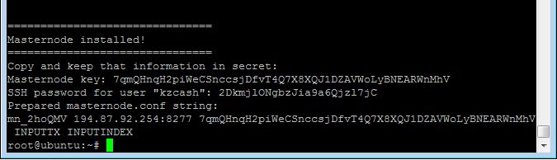

STEP 4 - BROADCAST MASTERNODE

**4.1** Let's see if your 1000 KZC transaction to yourself has been confirmed (minimum 15 confirmations).

**4.2** On your desktop wallet, go to **Tools->Debug Console.** In text box below run the following command

masternode outputs

It should print something like this:

{

"256842fn36e2cba66ab277fc9e3c51d2df1ed35e79442a3d01fbf8ee67ko76aw": "1"

}

For example:

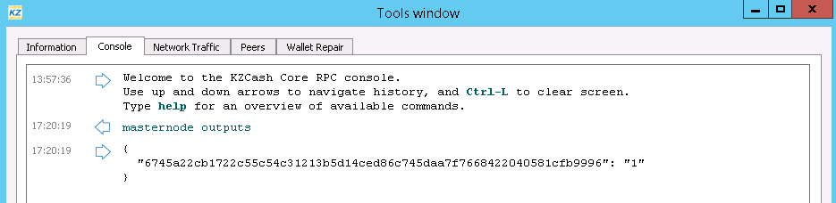

This is the transaction that would be used to keep masternode aknowledged by KZC network. Long part - is a transaction id. Short number - is a transaction index. Copy them too, you will use them shortly.

*Note: Keep those two values without quotes (").*

**4.3** Go to **Tools -> Masternode configuration file.** It will open your masternode.config file. It's needed for starting and tracking your masternode remotely.

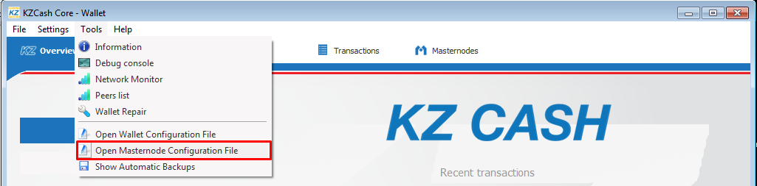

**4.4** Paste here prepared masternode.conf string that we've received on step 3.4.

**4.5** Replace INPUTTX with long transaction id, and INPUTINDEX with short transaction index that we've kept on 4.2. Click "Save" and close this config.

Example:

*mn1 127.0.0.2:8277 93HaYBVUCYjEMeeH1Y4sBGLALQZE1Yc1K64xiqgX37tGBDQL8Xg 2bcd3c84c84f87eaa86e4e56834c92927a07f9e18718810b92e0d0324456a67c 0*

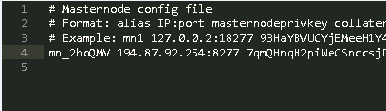

**4.6** Go to **Settings -> Options -> Wallet** and enable "Show Masternodes Tab".

**4.7** Restart the wallet.

**4.8** Important!

Wait for wallet finish syncing. There must be no "out of sync" or "synchronizing masternodes" messages. It could take a couple of minutes.

Only then follow 4.9.

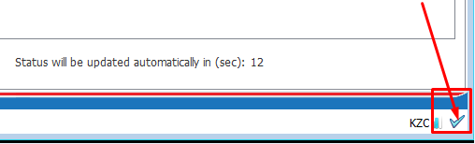

**4.9** Go to "Masternodes" tab. You should see your masternode. Select it and run "Start alias".

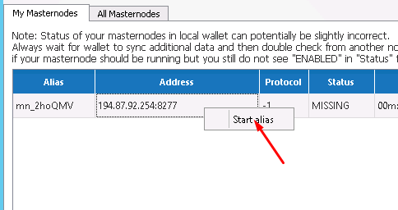

*Congrats! You've broadcasted your masternode to the* KZC *network.*

*Now it would go into state PRE_ENABLED, and after some time become ENABLED.*

*If so, you are all set. Your masternode will start getting rewards in about few hours.*

*If after 40min your masternode wouldn't become ENABLED, try doing 4.9 again and wait until it goes ENABLED. If this wouldn't help, feel free to ask our support for some advice.*

